# Database Architecture

**ThreeTier**

**One Tier**

**Two Tier**

# One Tier Architecture

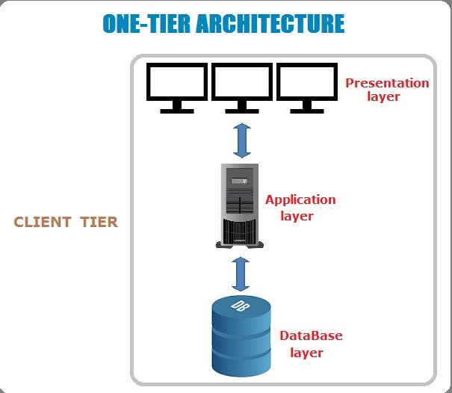

## Two Tier Client/Server Architecture

Application

Program



User

Client

Database Server

DBMS

Database

Application

Program



User

Client

**Direct Communication**

**Faster Communication**

ODBC

ODBC

## Two Tier Client/Server Architecture

* Two tier client/ server architecture is used for application programs that runs on client side.
* Clients are directly interacts with the database.
* An interface called ODBC (Open Database

Connectivity) provides an API that allow client side program to call the DBMS.

## Three Tier Client/ Server Architecture

Conceptual Level/ Logical Level Internal Level

Web Server Database Server



User

Client

DBMS

Database

Application

Server

Business Logic

Like:- Validation, Calculation,

Manipulation of Data

Facebook

External level/ View Level